Functional Requirements FOR HALLS;

Jo jo rights halls wale k honge mere platform pr
- Register/Login for halls owner with hall name not their personal names
- Calenders ki date update cancel confirm krna or mujhe inform krna
- Jo jo customers ne kis date ko book krwaya h un sb ki details ko dekhna
- Manually approve ya cancel krna request ko
- Apne expenses ko daal skta ho add ya minus krskta ho mujhe notify ho
- Customer k feedback dekh skta ho

For Customers
Almost jitne bhi tables honge wo customer ki requirements me jayej ge

Ab isme neeche whatsapp ka baar add check krna h chota sa take customer hall management se contact krske

NON-FUNCTIONAL REQUIREMENTS
Non functional requirements me system mi performance waghera jayegi jese scalabity
Performance time fr security usability backup system

Non functional requirements me system ki efficiency

1)power
2)speed
3)accuracy
4user handling
5)Scalibility
6)security

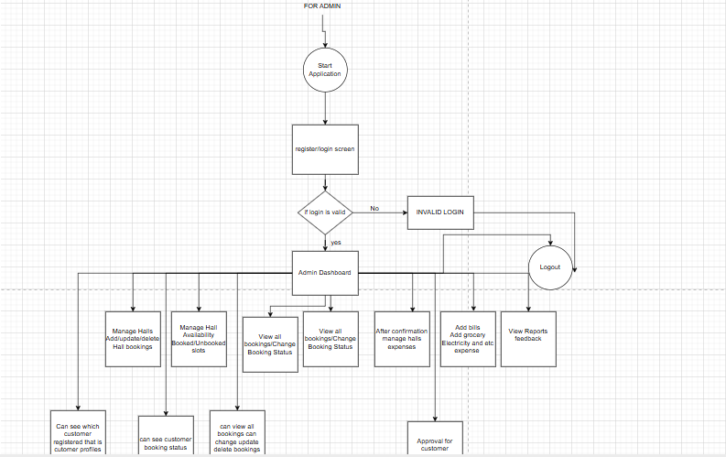

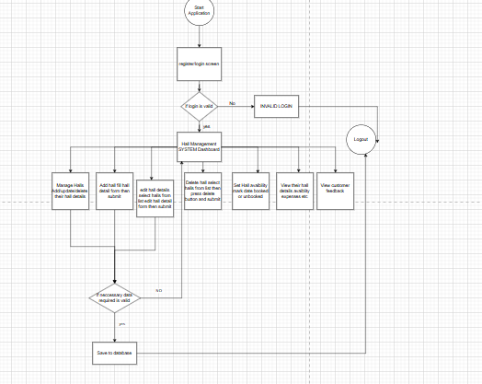

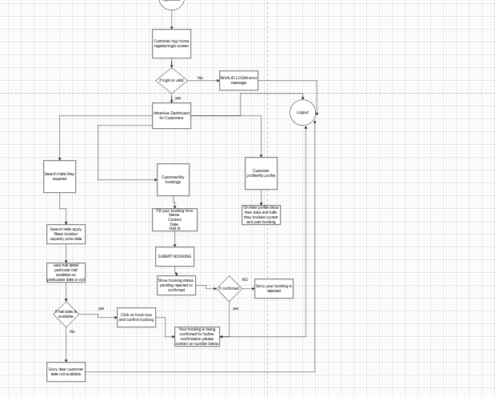

Admin Dashboard functions in backend

• Admin Login
- POST /admin/login
• Dashboard Stats
- GET /admin/dashboard/stats → returns total halls, bookings, customers, and upcoming bookings
• Marriage Hall Management
- GET /admin/halls → view all halls
- POST /admin/hall → add a new hall
- PUT /admin/hall/<hall_id> → update hall details
- DELETE /admin/hall/<hall_id> → delete a hall
• Availability Management
- POST /admin/hall/<hall_id>/availability → set available dates
- GET /admin/hall/<hall_id>/availability → view availability
• Booking Management
- GET /admin/bookings → view all bookings
- GET /admin/bookings/search → search bookings by name/date
- PUT /admin/bookings/<booking_id>/confirm → confirm booking
- PUT /admin/bookings/<booking_id>/cancel → cancel booking
• Customer Management
- GET /admin/customers → view all customers
- DELETE /admin/customers/<customer_id> → remove a customer
• Reports & Analytics
- GET /admin/reports/most-booked-halls
- GET /admin/reports/booking-trends

